Dear Ms. Sheah Welthee,

The Brilliant Aggies Financial Services have conducted research to help conduct and easily advise you on the smarter and more beneficial decision for you to invest your money. The consumer electronics retail industry has sparked our attention and interest. Best Buy INC. and GameStop were our two main prospects within this industry. Consumer electronics retail a plethora of appliances such as electrical goods, entertainment products, and electrical devices. More specifically, this industry hosts products such as smartphones, TVs, laptops and computers, video games and game systems, and many more products within the range of electronics and entertainment devices. Through our extensive research, it has been determined that Best Buy is a smarter and safer option for current and future investments.

The Brilliant Aggies Financial Services are aware of the investment being a long-term commitment, so we have to take into account trends and consumer habits within the industry. We also have to consider the climate of the economy. The biggest thing affecting all aspects of the world right now is COVID-19. There has been a historic drop in consumer spending habits and income. Many different industries are going to suffer and have been suffering economically as a result of the pandemic and damaged economy. Certain industries have had more drastic changes due to the impact of COVID-19, whilst other industries and stores have thrived due to less physical interaction and limited accessibility to other industries. According to IBIS World’s analysts, “Consumer Electronics Stores industry revenue is anticipated to fall 10.0% in 2020 due to economic slowdowns and temporary store closures as a result of the COVID-19 (coronavirus) pandemic” (IBISWorld 2020).

The hurt economy and industries have been forced to lay off a multitude of employees and cut hours of current workers and stores. Many stores within many different industries have been forced to be shut down completely for a lengthy amount of time. This was crucial in impacting the performance of the stores and the industry. Luckily for our selected industry, online shopping has been a huge key in helping the industry stay afloat and diminish any other underlying factors that can hinder success. According to the Wall Street Journal, “Since the pandemic began, growth of digital commerce has accelerated for retail and consumer products. In July, online sales grew 55% year over year, to $66.3 billion. Mobile sales have been on the rise for some time, accounting for nearly 75% of the $72 billion incremental e-commerce growth in 2019” (Lobaugh 2020).

The horizontal analysis conducted by our financial services has unraveled how Best Buy and GameStop responded and continued familiar operations while undergoing these changes and trends. Our horizontal analysis has determined that Best Buy has been more equipped to handle changes within the economy. Best Buy net sales have increased roughly by 2% in 2020 from 2019 and have continued to increase in prior years with the exception of a minor 1% decline in 2017. With the set base year of 2016, Best Buy’s net sales have grown about 10% in the last 4 years. GameStop has had a much harsher and unfortunate time. They experienced a huge loss in the transition from 2018 to 2019. Given the same base year of 2016, GameStop has grown 7%, to then declining by 4%, and then a huge drop in net sales by 22.82% from 2018 to 2019. This is huge considering that this drop in revenue happened prior to the COVID-19 pandemic. Best Buy having more broad and versatile products is the key factor in why they performed better than GameStop. GameStop, among numerous other companies in this industry, has experienced some form of loss. Best Buy has the ability to consistently progress in sales prior to the pandemic, and even during the pandemic, shows that the company can adapt to harsh times, trends, and difficulties in the economy.

COVID-19 has halted many different aspects of the economy while also exposing many different characteristics of certain industries and stores. COVID-19 has given our services the ability to assess how each store in the same industry has been influenced by COVID-19, and how they responded. Best Buy has experienced a loss in total assets, although the loss was not significant in any way. Best Buy lost less than .01% in total assets in 2020 from 2019, therefore, proving to not be significant. GameStop, however, has suffered tremendously with a 47.8% loss in assets from 2019 to 2020. Best Buy has shown to be an extremely beneficial investment based upon the horizontal analysis in comparison to GameStop. The only factor GameStop has beaten Best Buy in is decreasing its total amount of long-term liabilities. Although GameStop has more effectively decreased their liabilities, they still have an incredibly unimpressive amount of total liabilities and stockholders’ equity in comparison to Best Buy.

 How is the future looking for the electronic consumer industry? “GlobeNewswire states that the global consumer electronics industry is expected to register considerable growth over the forecast period 2019-2025. Increasing demand for products such as televisions, smartphones, and wearable devices is one of the primary driving factors for the global consumer electronic market. Rising disposable income coupled with increasing adoption of smart devices, technology proliferation, development of semiconductor industry, and increasing penetration of the internet of things (IoT) is further fueling the growth of the consumer electronic market” (GlobeNewswire 2020). This industry is still in shape to be in a preferential position given the projections in surging need and importance of online shopping and electrical devices and services. GameStop can possibly alleviate current issues and better propel itself into good standing. GameStop will need to broaden its inventory of goods and services in order to repair itself, therefore the company can be deemed more essential allowing it to prosper economically. Best Buy, along with the other companies within the industry, will also need to strategize and carefully navigate how they want their businesses to operate given the unfortunate economic circumstances. The future is said to be positive, however, companies still have to ready themselves for unforeseen scenarios. There are still heavy doubts about when and how long it will take for us to overcome the impact of the pandemic, so companies will have to put forth extreme efforts to become and remain profitable.

A vertical summary also referred to as a common size analysis looks at each line item as a percentage. This is similar to a horizontal summary but the differences with those look more in-depth at the dollar amounts. After Comparing the two companies with the information provided, we did notice some remarkably interesting things. We have to consider the differences and versatility of each store and what they offer to consumers. Kasey Lobaugh of the Wall Street Journal suggests that “When “nonessential” physical retail locations closed during the pandemic, many consumers shifted their spending to select retailers that could provide essentials along with conveniences such as same-day delivery and real-time inventory updates. The continued effects of COVID-19 could fuel retail consolidation, creating an environment where a limited number of companies emerge stronger at the expense of smaller or independent ones” (Lobaugh 2020). GameStop is mainly for video games and things of that genre. Numbers tend to be a lot less than Best Buy. Based on the vertical analysis one clear indication of why that could be the case is based on the cost of goods sold. This equates to at least 70% on both company’s stats. Again, Best Buy is a merchant who sells an abundant amount of technological items ranging from kitchen appliances to other products like TVs and video games. Therefore, items at Best Buy consumables can range anywhere from a few dollars to more expensive ones that cost upwards of five to ten thousand dollars. If you were to compare that to a GameStop there would be a significant difference. By looking at the vertical analysis you can also see what makes up net sales which generally is the all-inclusive amount on how much the company has made in total. This is why that category will always show up as 100. From there all categories included in the vertical summary will make up a whole.

Now let us compare the companies hand to hand. Both companies have stats that deferred from the past year drastically but one more than the other. This is based on our biggest issue which is COVID-19 which has impacted us all greatly.  To ensure the safety and wellness of all citizens we have now had to adopt new measures. All positive changes in the right direction to keep customers safe but this has led to the unfortunate circumstances of store closings or other resorts like reducing traffic and quantity at local brick and mortar stores, as all actions have consequences. Given a lot, many of us are now working from home and Schools have also migrated online. Places like Best Buy in some areas are considered essential stores. How might one ask? This can be better explained when considering the need for technology during this current pandemic. Since Best Buy has a broad number of products, they are able to service customers who have a need for Internet and other products to continue to try and help resume their daily life back to normal as much as possible. With all of that being said these companies are still striving through difficult times such as these because of technology being some of the most important items around this time in the world.

Another particularly important category in the vertical summary is the gross profit. This is the amount that the company takes home after paying for fees and Other expenses. Generally, after the cost of goods is subtracted from net sales generally most of the amount left over is going to be the gross which again is the take-home profit. If we take a look at Best Buy in 2019 the gross profit was 23% (Buy Inc., 2019). Fast forward to the 2020 fiscal year and it shows 23% gross profit (Buy Inc., 2020). Based on this information provided in the vertical analysis no big change was made with the company but on the other hand, GameStop in 2019 gross profit was 35% (Sherman, 2020). Based on their 2020 stats the new gross profit is 27% (GameStop, 2020). This decline is not the same as Best Buy which again factors down to some Best Buy’s being able to continue serving customers at brick-and-mortar stores as GameStop is not considered essential which entails the negative stats.

Sequentially this goes hand-in-hand with company size. When one thinks of GameStop you think of small locations with lots of merchandise. In 2020 we all have to be very cautious and respectful of other spaces. Most governments in the United States mandated the citizens in public give each other 6 feet or more of space surrounding them. To smaller employers this most likely meant less inventory, and to bigger employers not only did it yield less inventory it also meant for some big names to scale back employees to keep from going under financially. As of February 1, 2020, game stop has a total of 3642 domestic stores in the US according to gamestop.com (Sherman, 2020). The latest info on Best Buy states that only 900+ are based here in the US (Tankovska, 2020). During the first stages of the pandemic, almost half of them were shut down until further notice. While this was happening most stockholders and shareholders were very afraid of a crashing market so many of them cashed on stocks to keep from taking losses.

When it comes to assets Best Buy completely blows GameStop out of the water. This is due to a variety of different factors. One of the biggest of said factors is the fact that GameStop is a company focused exclusively on the sale of video games and video game-related merchandise. Whereas Best Buy is a company that focuses on the sale of just about anything that could be considered as a part of the electronics market. As a result, despite the fact that GameStop has managed to achieve quite a lot of market penetration in the video gaming space, their assets just can’t measure up to a company like Best Buy that has managed a similar level of market penetration in a field like electronics which is much wider than the narrow video games market.

As far as liabilities go, both GameStop and Best Buy run into similar problems as we detailed above about assets. That being that despite how well GameStop is doing in the video game market as a whole, they just can’t match up to Best Buy’s penetration of the much larger electronic market. But while this may hurt GameStop in the assets department, it is a boon as far as Liabilities go. The smaller nature of the video game market means that the number of liabilities that GameStop has to shoulder are much smaller than the ones that a company like Best Buy who is a major competitor in the electronics market has to suffer.

When you compare GameStop and Best Buy in terms of Liquidity, GameStop comes out ahead for a variety of reasons. If we had to choose the biggest reason for this then we would say it is because of the types of products that both companies sell. GameStop’s focus on video games and video game merchandise results in their company being fairly easy to liquidate. Best Buy on the other hand would have a much harder time liquidating due in major part to how widespread and varied the electronics market has become over the years. In this case, GameStop’s focus on an awfully specific part of the electronics market helps them when compared to Best Buy’s more spread out and varied approach.

When you go purely by the numbers GameStop has Best Buy beat as far as profitability goes. This is due to a variety of factors, one of the biggest being the overall profit margin each company has. GameStop’s profit margin is bigger than Best Buy’s in large part due the fact they choose to focus on the relatively cheaper video game market over the more expensive electronic market. A single device in the electronics market is usually fairly expensive to produce and as a result, the profit one can make off of them is much more limited if they want to stay competitive in the market. A single video game on the other hand is much cheaper to produce due in part to the fact that the majority of the price in making a video game is spent in development and thanks to GameStop’s status as a retailer they don’t have to worry about that very much.

When comparing both companies' solvency measures, we would have to give the advantage to Best Buy. This mainly comes down to the fact that Best buy’s interest Coverage Ratio is just so much better than GameStop’s. While GameStop is not doing too bad as far as the solvency measures are concerned, the fact of the matter is that they do not stack up to how well Best Buy is doing. And when you factor in the fact that both company’s Debt-To-Equity Ratios and Debt Ratios are within a comparable margin it becomes quite easy to see that Best Buy has a firm lead over GameStop in this category.

From a quantitative point of view, GameStop does not appear to be doing very well. Their business relies heavily on selling hard copies of video games to consumers, but recent changes in the video game market have led to an increase in the number of consumers wishing to purchase digital copies of video games from online distributors. This uptick in the number of consumers wishing to go digital has led to an overall decrease in the number of consumers they can expect to frequent their stores. This has been made even worse with the arrival of COVID leading to many people choosing to avoid going to GameStop and instead buy digital so as to avoid subjecting themselves to more risk than they absolutely have to.

GameStop also does not appear to be doing very well from a more qualitative point of view. From 2016 to late 2019 GameStop was experiencing a record decline in sales, a decline which they only appear to have started to recover from relatively recently (Carter, 2020). When you combine this with the fact that 321 stores were closed in 2019 and over 400 stores are set to be shut down throughout 2020 (Humphries, 2020). This hard data when combined together does not point to anything good regarding GameStop’s future. With the video game market currently experiencing record video game sales even as GameStop continues to shut stores down for underperforming one has to worry about what the future holds for the company (Perez, 2020).

                Best Buy by comparison to GameStop appears to be doing surprisingly well from a Quantitative point of view. Best Buy was already doing fairly well as a business before all the problems with COVID began and with its rise, the company appears to only be doing better and better (Reilly, 2020). With more and more people being forced to either work from home or spend the majority of their free time at home the demand for electronics has seen a notable rise and Best Buy is in the perfect place to take advantage of this increase in demand (Rivas, 2020).

  From a qualitative point of view Best Buy is doing amazing. Their stock prices have been on the rise this year and many news outlets are even declaring that the company is set to be one of the winners of retail when the COVID pandemic finally comes to a close (Anderson, 2020). Combined with the fact that Best Buy recently saw its online business in the United States grow 242 percent in just under 3 months (Anderson, 2020). It is safe to say that Best Buy is a company currently on the rise and as long as they can retain their current momentum then the future looks bright for the company as a whole.

The multiple different analyses conducted by our financial services have determined that Best Buy INC. is a significantly better option to invest in rather than GameStop. GameStop needs to undergo many different changes to compete with the other companies in its industry. The culture at GameStop has to improve. The demanding, ongoing, and varying trends with consumer spending habits have been tough to manage for GameStop to moderate. They experienced a steady decline in revenue and gross profit. GameStop has been losing its popularity. There is a bright spot for GameStop. As stated earlier, the electronic consumer industry is projected to experience success as a result of increasing online shopping and electrical demands. There has to be initiative for GameStop to take in order to fully capitalize off of the harsh and unfortunate conditions of the pandemic. A call for a change in leadership, supply chain management, and overall direction can very well stir GameStop on the up and up.

 The comparison of GameStop and Best Buy shows a number of very important things. Industries that focus on retail and have the option and privilege of online shopping are able to pull their own weight and maintain a profitable business, regardless of many factors, such as decreased physical interaction, declining economy, shifting demand, and consumer budget and income. Best Buy is a good example of how to handle change, and GameStop is on the opposite side of the spectrum. Investing in Best Buy is an astronomically preferential choice given these factors. In order for GameStop to compete, there must be a change. Their situation is not all bad, but Best Buy has proved to be a smarter and more well-versed company. You may feel that, given GameStop’s limited variety of products, it is in an unfair position to be competitive with more broad and versatile businesses such as Best Buy. GameStop still has the potential to be a competitor in the same industry as Best Buy. For example, Chick-fil-a is one of the top fast-food restaurants every year in terms of sales, and they are closed on Sunday’s, while a plethora of trailing fast-food restaurants are open seven days a week. That is because Chick-fil-a has built an exceptional reputation for their customer service and quality of food items. GameStop needs to follow the blueprint of successful companies to compete and thrive. Best Buy is still in a position to lose money despite the projections. They could ruin their opportunity to take advantage of the trends and pandemic. There have been two huge new additions to the electronic and entertainment industry. The next generation consoles of Sony’s PlayStation and Microsoft’s Xbox will be in extremely high demand, especially during the holidays. GameStop, whose main priority is the gaming aspect of the electronic consumer industry, needs to insert itself at the front of the line in front of all other competitors in the same industry. This can be done by acquiring those specific assets to their inventory more than their competitors. Best Buy is the smarter option because they have proven they can handle change and sustain consistent net sales, however, GameStop, just like Chick-fil-a, can build a loved reputation and heavily improve their sales and maybe even surpass Best Buy, among many other competitors in a few years time.

In conclusion, the Brilliant Aggies Financial Services recommend Best Buy INC. as your overall best choice for long term investment in the electronic consumer industry. Best Buy is currently leaps above GameStop in terms of sales, assets, and potential profitability, Best Buy has established itself as one of the heavy hitters of its industry and GameStop, even before the harsh effects of COVID-19, have struggled to keep up with its competitors.

Sincerely, The Brilliant Aggies Financial Services

Jalan Neal

Acascia Stanley

Xavier Glover

References

Anderson, G. (2020, August 26). *Best Buy produces record results doing things differently in the pandemic*. RetailWire.

Retrieved from: <https://retailwire.com/discussion/best-buy-produces-record-results-doing-things-differently-in-the-pandemic/>.

Buy Inc., B. (2019). 2019 Annual report.

Retrievedfrom:<https://www.sec.gov/Archives/edgar/data/0000764478/000076447819000009/bby-2019x10k.htm>

Buy Inc., B. (2020). 2020 Annual report.

Retrieved from:<https://www.sec.gov/Archives/edgar/data/0000764478/000076447820000017/bby-20200201x10k.htm>

Carter, A. (2020, October 25). *Why GameStop Could Go Out Of Business In The Digital Age*. Game Rant.

Retrieved from: <https://gamerant.com/gamestop-out-of-business-in-digital-age/>.

GameStop, G. (2020). 2020 Annual report.

Retrieved from: <https://www.sec.gov/Archives/edgar/data/0001326380/000132638020000022/a10k-fy19q4.htm>

GlobeNewsWire. *Impact of COVID 19 on Consumer Electronics Market*

Retrieved from: <https://www.globenewswire.com/news-release/2020/04/17/2017894/0/en/Impact-of-COVID-19-on-Consumer-Electronics-Market.html>

Humphries, M. (2020, September 11). *GameStop Is Closing Up to 450 Stores This Year*. PCMAG.

Retrieved from: <https://www.pcmag.com/news/gamestop-is-closing-up-to-450-stores-this-year>.

Lobaugh, K. (2020, November 12). 7 Trends Disrupting Retail and Consumer Products. Retrieved from: <https://deloitte.wsj.com/cmo/2020/09/04/7-trends-disrupting-retail-and-consumer-products/>

Perez, M. (2020, August 10). *U.S. Video Game Sales Set Record Second Quarter, Spurred By Pandemic*. Forbes.

Retrieved from: <https://www.forbes.com/sites/mattperez/2020/08/10/video-games-set-record-second-quarter-spurred-by-pandemic-sales/?sh=186db6876f4e>.

Reilly, M. (2020, May 19). *Best Buy reports earnings this week, but some say it is already won*. bizjournals.com.

Retrieved from: <https://www.bizjournals.com/twincities/news/2020/05/19/best-buy-surges-after.html>

Rivas, T. (2020, May 18). *Best Buy May End Coronavirus Pandemic as a 'Winner in Retail'*. Best Buy May End the Coronavirus Pandemic as a 'Winner in Retail' | Barron's.

Retrieved from: <https://www.barrons.com/articles/best-buy-sales-earnings-ugrade-outlook-coronavirus-pandemic-51589815068?siteid=yhoof2>.

Sherman, G. (2020). 2019 Annual report.

Retrieved from: <http://news.gamestop.com/static-files/9d2139e1-31c7-498f-ad95-63db1e6d085a>

Smith, N. (2020, May 14). *The giants of the video game industry have thrived in the pandemic. Can the success continue?* The Washington Post.

Retrieved from: <https://www.washingtonpost.com/video-games/2020/05/12/video-game->industry-coronavirus/.

Tankovska, P., & 9, S. (2020, September 09). Total number of Best Buy stores, by segment U.S. 2020.

Retrieved from: <https://www.statista.com/statistics/249558/total-number-of-best-buy-stores-in-the-united-states-by-segment/>

Horizontal Analysis

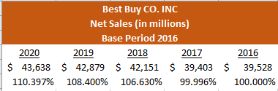

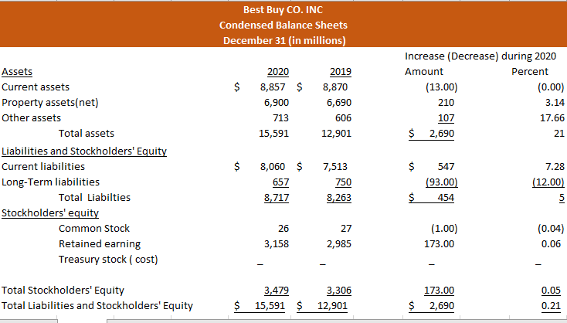

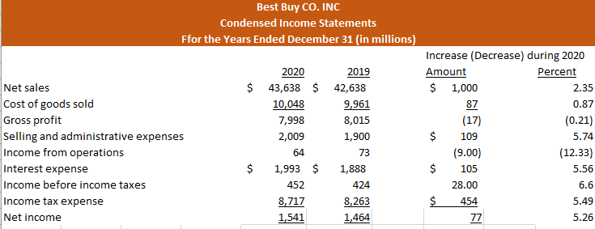

Horizontal Analysis

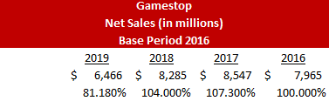

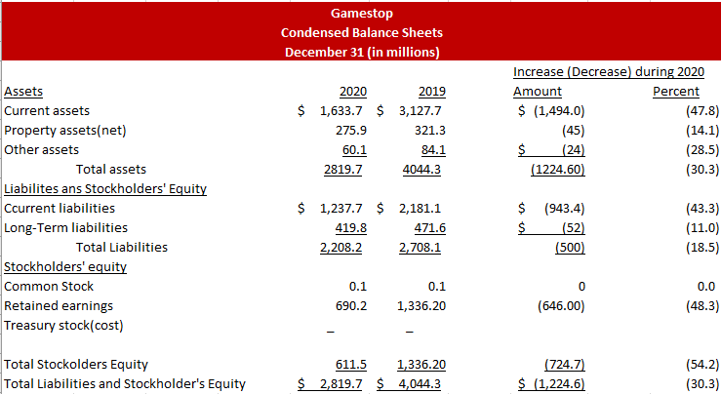

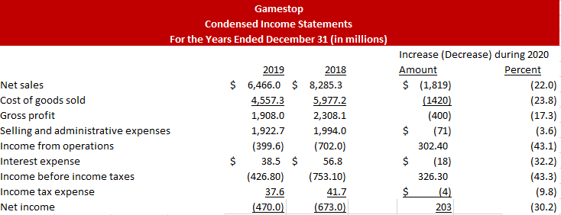

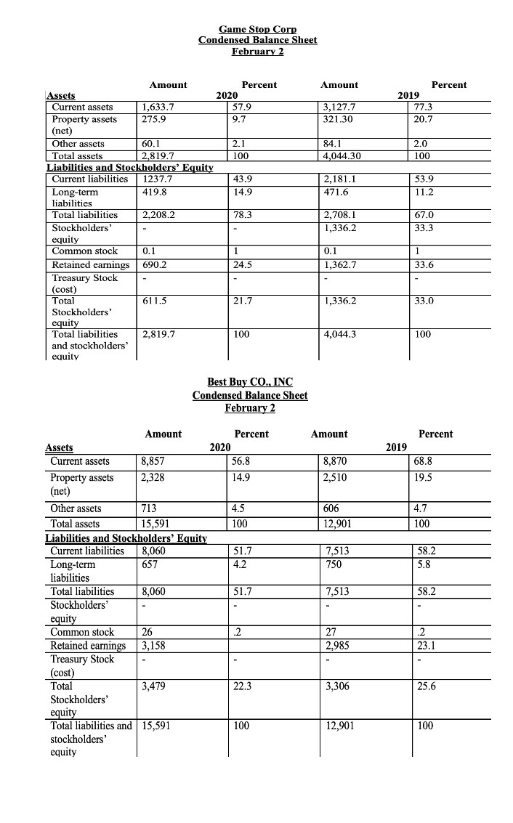

Vertical Analysis

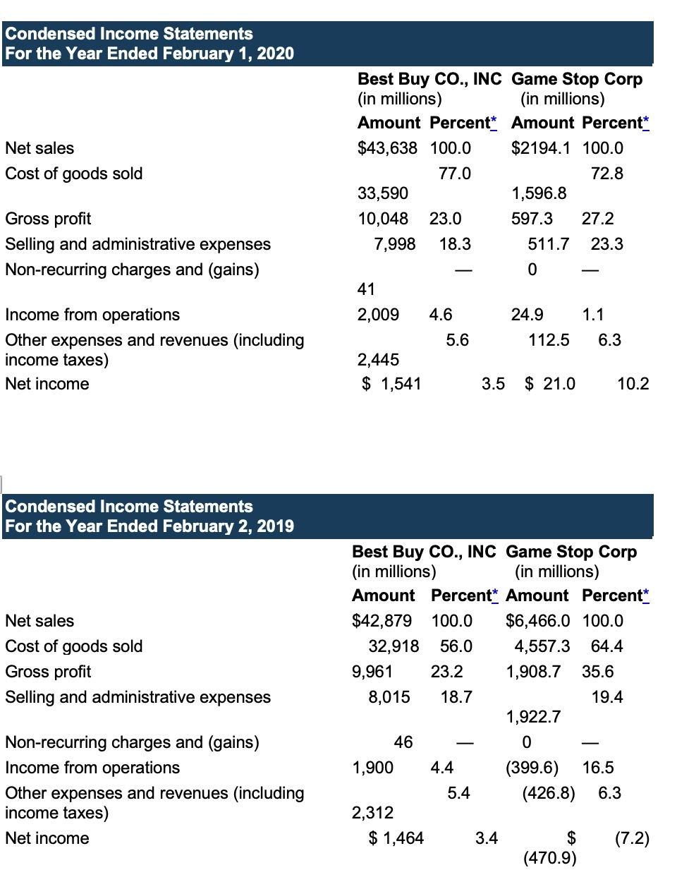

Vertical Analysis

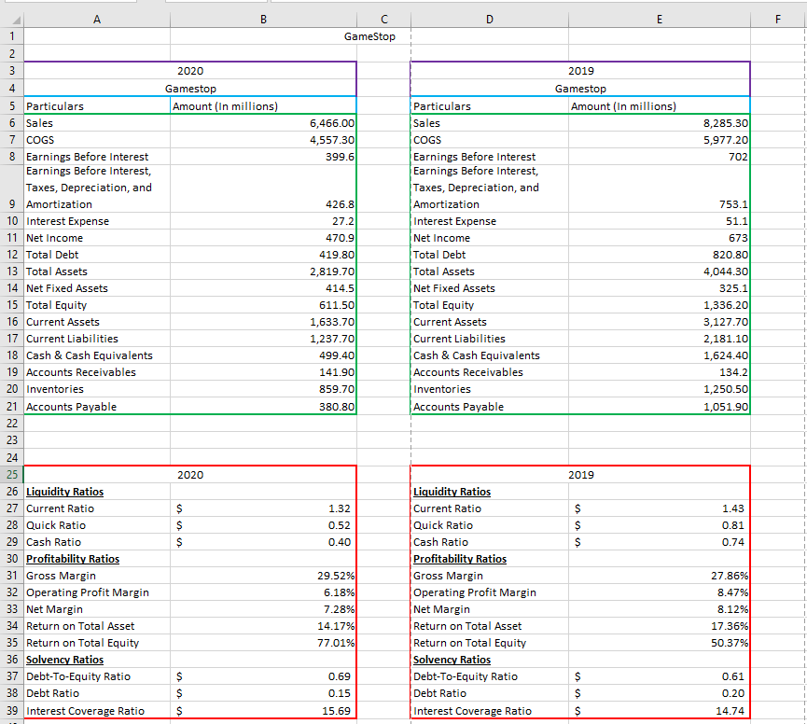

Ratio

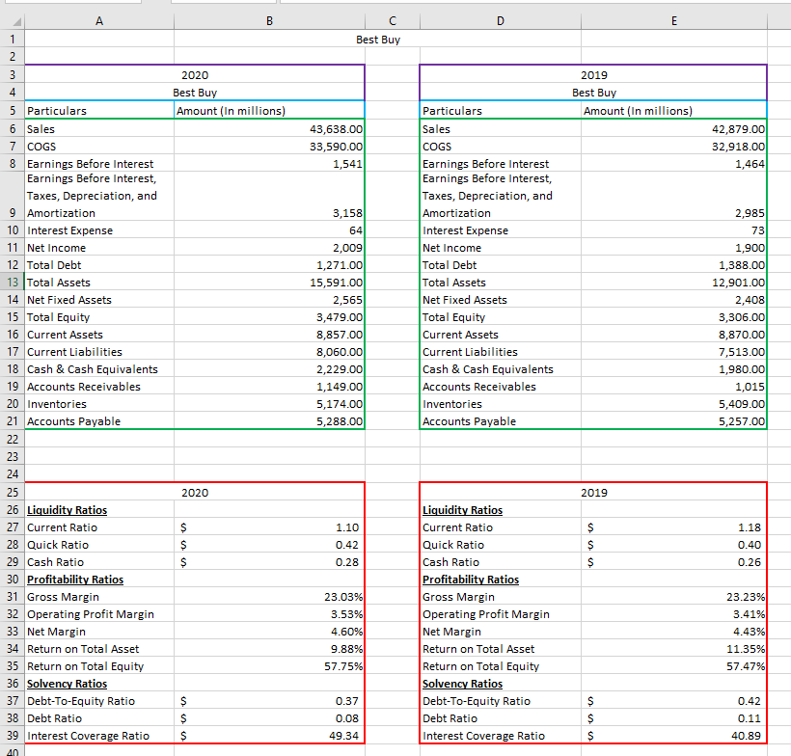

Ratio

